# **Practical No – 06**

# **Regression and Its Types**

a) Implement simple linear regression using a dataset.

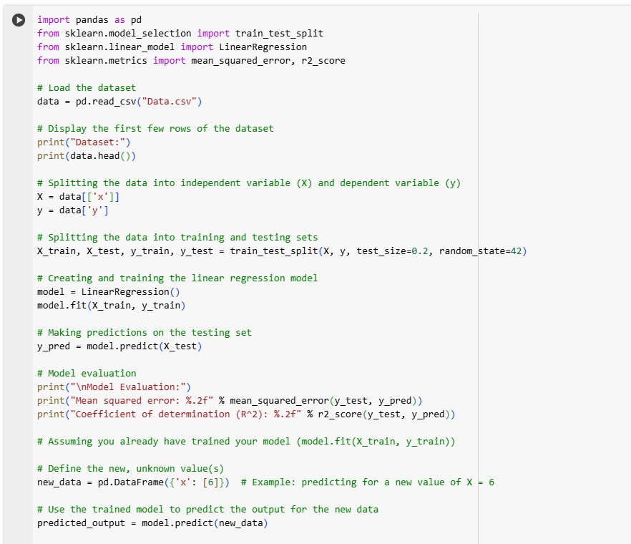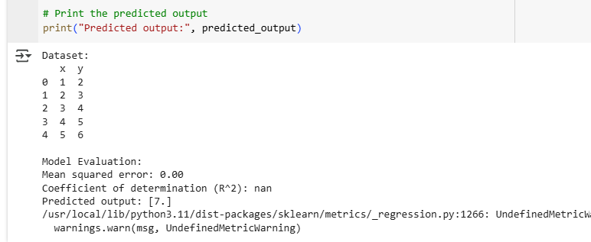

b) Explore and interpret the regression model coefficients and goodness-of-fit measures.

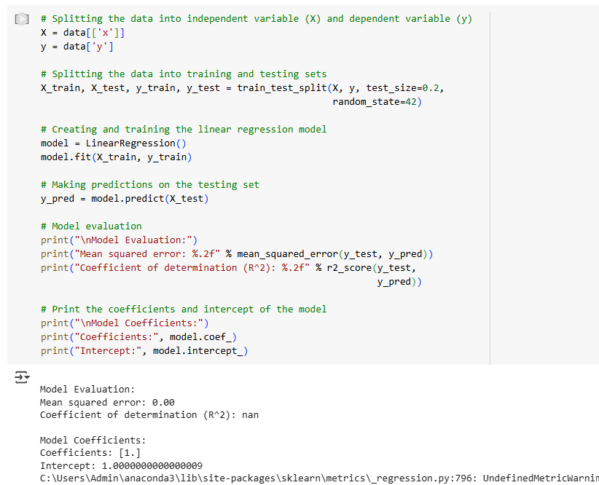

c) Extend the analysis to multiple linear regression and assess the impact of additional predictors.

